A new book - Every new book project starts small and after beginning research on the new “Doctors of Sandy Creek” book we realize what a big project it actually will be. This community has had the great good fortune to have been served by competent and dedicated doctors, from the time people first settled here in the early 1800’s right down to the present time. The first physician in this area was a Dr. Porter, about whom not too much is recorded. We must give the honor of being the first local resident doctor to Dr. James A. Thompson, who came in 1815 and practiced medicine here for forty-four years, until his death. The County History (1789-1877) states also that his son, Dr. Allen Thompson, had been a doctor here for 43 years. This town has had several father and son combinations and three-generation group represented in the local medical profession.

This book will include 23 Doctors, 9 Dentists, 2 Optometrists and while we are at it we will include 8 Drug Stores. As always it is a team effort and my team includes Phyllis LeBeau, Irene Fuller and Joyce Miles. Phyllis who loves to research, Irene has helped with the typing and Joyce is working on improving access to the genealogy files while looking for more information. It takes a “team effort” to produce a book and we have a top notch team.

All this information has been gleaned from Sketches; Pauline Tanner & Nanette Hamer’s research; History of Oswego County, New York; Sesquicentennial 1825-1975; Landmarks of Oswego County; the History Center genealogy and obituary files; dwellings of Sandy Creek Village and Lacona Village by Sanford Wheeler; Sandy Creek News; Yesterday’s Album by Marie Parsons; “As I See It” by George Corse; and is a work in progress.

This book is due to be published in 2015.

Doctors:

Austen, Fred
Ayers, John G.
Bulkley, J. Lyman
Burton, Samuel L.
Chapin, Harvey E.
Cook, Newton
Crockett, Robert I.
Crockett, Samuel J.
Davis, George H.
Douglas, Solomon J.
Ellis, G. K.
Hamilton, Laura
Hollis, Harwood
Hollis, LeRoy
Hollis, Warren
Howard, James Spencer
Lounsbury, Charles E.
McChesney, Hugh
Reed, Birch R.
Swift, Dr.
Teed, Cyrus R.
Thompson, Allen L.
Thompson, James A.

Dentist:

Baker, W. G.
Baldwin, John J.
Budlong, Willis Arthur
Clark, Ross A.
Freeman, William
Huntington, Frederic
Lewis, Daniel W.
Rogers, Edwin G.
Thompson, James S

Optometrists

Allen, Jason Roy
Blodgett, Malcom S.

While researching the Doctor’s of Sandy Creek/Lacona book we have found some interesting information. This community has had the great good fortune to have been served by competent and dedicated doctors, from the time people first settled here in the early 1800’s right down to the present time (211 years). I share some of our research here:

      - About 1825 Dr Ayer is credited with being one of those who suggested changing Sandy Creek’s name to Washingtonville as it was thought desirable to have a “local” name for the little settlement where the Salt Road crossed Sandy Creek.
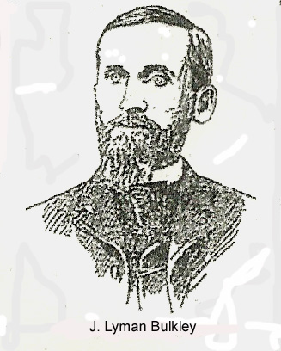
- The attempted murder of Dr. J. Lyman Bulkley by a patient who had just been released from the Ogdensburg State Hospital was big news in 1894. The young man had lived in Boylston and was a former patient of Dr. Bulkley.

- In the old days when travel in winter was by horse and cutter, Doctor LeRoy Hollis was called Up East one stormy day to attend to a patient who was dying. The roads were drifted and it was quite a trip. It was during the flu epidemic, and in the same household was another member of the family, also apparently at death’s door, so to save time and travel, Dr. Hollis signed another death certificate for him. The story was, however, that the second patient lived for some years afterward.

- One of Dr. Solomon J. Douglas patients was a school teacher, Mrs. Sage, who was ill with tuberculosis. She had three children, the youngest being only six months. Mrs. Sage realized she could not live and on one of the Doctor’s visits expressed her concern for the baby’s care after her death. Dr. and his wife, not having any children, adopted little Martha Sage.

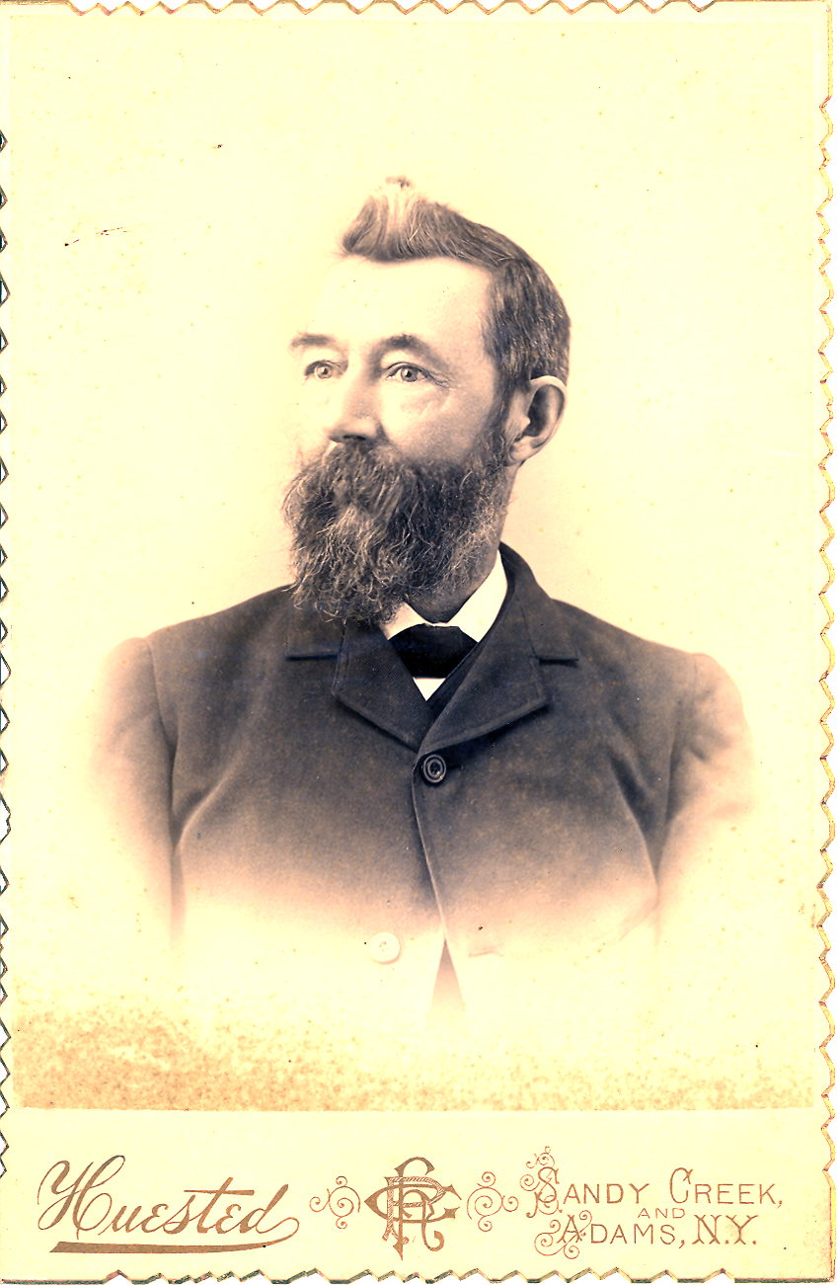
- Dr. Samuel Crockett was born in Baltimore Md, and was a graduate of the Jefferson Medical College of Philadelphia in 1866 and was a veteran of the Civil War. His biography in the Oswego County History says his medical education was interrupted when he enlisted as a cavalryman. He was in 34 battles and had six horses shot under him, but he was never wounded. However, he was taken prisoner and spent several months in a Rebel prison, and his health never fully recovered after that ordeal. He died in Sandy Creek March 23, 1906 at the age of 69 and is buried in Woodlawn Cemetery.
- Dr. Robert L. Crockett was born in Sandy Creek February 23, 1876. He was a graduate of Sandy Creek High School in 1894 and of Syracuse University in 1897. He practiced medicine here until about 1911, when he moved to Oneida, but even after moving away he continued a schedule which brought him to Sandy Creek at regular intervals. He was an eye, ear and throat specialist, and worked from his home on East First Street, and later in the office maintained over what was the Foderer Market in Sandy Creek. Dr. Crockett was a Major in the Army Medical Corps in the First World War.

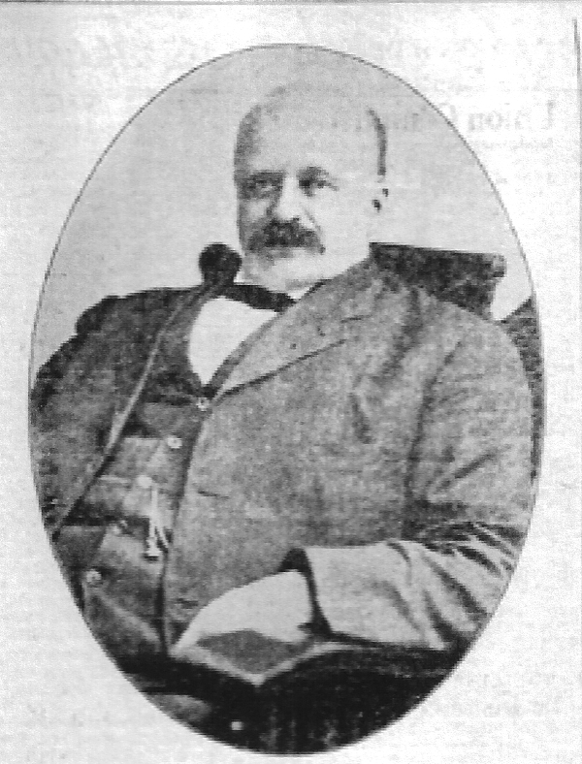
Dr. Newton Cook began the study of medicine in his home in Schoharie County, moved with his parents, Nicholas and Jane Newton Cook, to Sandy Creek in 1866 and continued his studies, or “read medicine” as it was termed in those days, with Dr. J. Lyman Bulkley. After he graduated from New York University Medical College in 1889 he came back here to establish his practice, which grew to be extensive, and one which he carried on for more than half a century, ministering faithfully to sick and afflicted in this and neighboring towns.

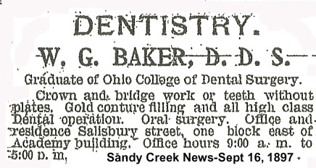

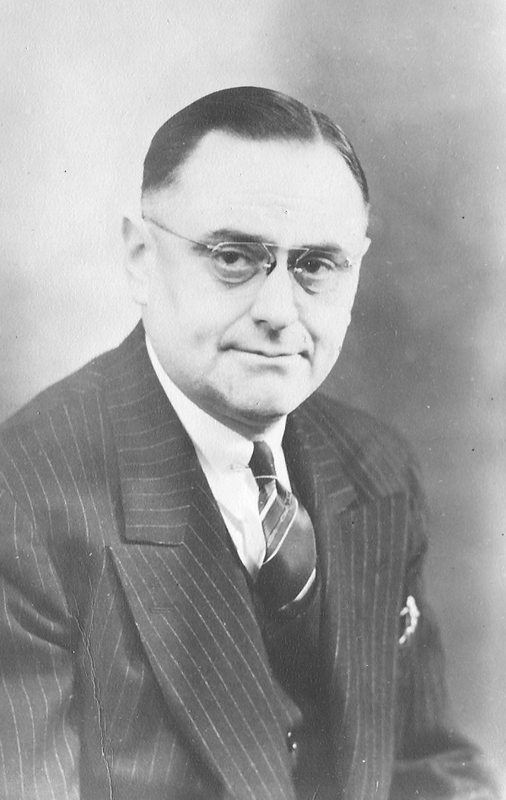
“As I See It” was recording the sorrow of the community over the sudden death of Dr. Harwood L. Hollis, who died April 28, 1947 while in his office talking with a patient. “Dr Harwood Hollis is one of Sandy Creek and Lacona’s doctors that our community will long remember and miss.”

